Practical 2:
Problem Statement:
Initiate the semester-long StudentHub portal by identifying the problem
scope, user roles, key modules, navigation flow, and minimum 10 pages.
Create a sitemap, low-fidelity wireframe, project folder structure,
README file, and GitHub repository.
Solution:
Index.html
<!DOCTYPE html>
<html lang="en">
<head>
<meta charset="UTF-8">
<meta name="viewport" content="width=device-width, initial-scale=1.0">
<title>StudentHub</title>
<link rel="stylesheet" href="css/style.css">
<link rel="preconnect" href="https://fonts.googleapis.com">
<link rel="preconnect" href="https://fonts.gstatic.com" crossorigin>
<link href="https://fonts.googleapis.com/css2?family=Playfair+Display:wght@500;600;700&family=Poppins:wght@300;400;500;600&display=swap" rel="stylesheet">
</head>
<body>
<section class="hero">
<div class="overlay">
<header>
<nav class="navbar home-navbar">
<div class="logo">
<a href="index.html">StudentHub</a>
</div>
<ul class="nav-links">
<li><a href="index.html">Home</a></li>
<li><a href="about.html">About</a></li>
<li><a href="events.html">Events</a></li>
<li><a href="faq.html">FAQ</a></li>
<li><a href="contact.html">Contact</a></li>
</ul>
<div class="nav-buttons">
<a href="login.html" class="login-btn">Login</a>
<a href="register.html" class="register-btn">Register</a>
</div>
</nav>
</header>
<div class="home-hero-content">
<p class="tagline">
STUDENT PORTAL
</p>
<h1 class="campus">
One Campus.<br>
One Platform.
</h1>
<p class="description">
Experience academics, campus events,
announcements and student services
through one modern digital platform.
</p>
<div class="hero-buttons">
<a href="register.html" class="primary-btn">
Register Now
</a>
<a href="about.html" class="secondary-btn">
Learn More
</a>
</div>
</div>
</div>
</section>
<section class="about">
<div class="container">
<div class="about-image">
</div>
<div class="about-content">
<span class="section-tag">
ABOUT STUDENTHUB
</span>
<h2>
A Modern Student Portal Designed
For Every Campus
</h2>
<p>
StudentHub is a centralized platform that
connects students with academics,
announcements, events and important
college services. It simplifies campus life
by bringing everything together in one
easy-to-use portal.
</p>
<div class="about-features">
<div class="feature">
<h4>🎓 Academics</h4>
<p>Access academic updates and resources.</p>
</div>
<div class="feature">
<h4>📅 Events</h4>
<p>Register for workshops and college events.</p>
</div>
<div class="feature">
<h4>📢 Notices</h4>
<p>Never miss important announcements.</p>
</div>
<div class="feature">
<h4>👤 Student Profile</h4>
<p>Manage your profile from one dashboard.</p>
</div>
</div>
<a href="about.html" class="primary-btn">
Discover More
</a>
</div>
</div>
</section>
<section class="events">
<div class="container">
<div class="section-heading">
<span class="section-tag">
UPCOMING EVENTS
</span>
<h2>
Explore Campus Activities
</h2>
<p>
Participate in workshops, hackathons,
seminars and cultural festivals.
</p>
</div>
<div class="event-grid">
<article class="event-card">
<img src="images/hackathon.jpeg" alt="Hackathon">
<div class="event-info">
<span>15 AUG 2026</span>
<h3>
Annual Hackathon
</h3>
<p>
Compete with innovative minds
and solve real-world challenges.
</p>
<a href="events.html">
Read More →
</a>
</div>
</article>

<article class="event-card">
<img src="images/workshop2.jpeg" alt="Workshop">
<div class="event-info">
<span>28 AUG 2026</span>
<h3>
AI Workshop
</h3>
<p>
Learn AI and Machine Learning
from industry experts.
</p>
<a href="events.html">
Read More →
</a>
</div>
</article>

<article class="event-card">
<img src="images/event.jpeg" alt="Cultural Fest">
<div class="event-info">
<span>05 SEP 2026</span>
<h3>
Cultural Fest
</h3>
<p>
Celebrate creativity,
music and talent.
</p>
<a href="events.html">
Read More →
</a>
</div>
</article>
</div>
</div>
</section>
<section class="testimonials">
<div class="container">
<div class="section-heading">
<span class="section-tag">STUDENT STORIES</span>
<h2>What Our Students Say</h2>
</div>
<div class="testimonial-grid">
<div class="testimonial-card">
<div class="testimonial-card featured">
<div class="quote">❝</div>
<div class="stars">
★★★★★
</div>
<p>
StudentHub makes college life much easier by
keeping academics, notices and events together
in one place.
</p>
<h4>Aryan Parmar</h4>
<span>Electronics & Communication Student</span>
</div>
</div>
<div class="testimonial-card">
<div class="testimonial-card featured">
<div class="quote">❝</div>
<div class="stars">
★★★★★
</div>
<p>
The portal is clean, intuitive, and saves time by
providing quick access to announcements,
resources, and campus updates.</p>
<h4>Vaidehi Parmar</h4>
<span>Computer Science Student</span>
</div>
</div>
<div class="testimonial-card">
<div class="testimonial-card featured">
<div class="quote">❝</div>
<div class="stars">
★★★★★
</div>
<p>
Registering for workshops and college events
has become quick and hassle-free.
Everything I need is just a click away.
</p>
<h4>Lisha Mansuri</h4>
<span>IT Student</span>
</div>
</div>
</div>
</div>
</div>
</section>
<section class="cta">
<div class="container">
<h2>
Ready To Join StudentHub?
</h2>
<p>
Stay connected with academics,
events and campus life through
one smart platform.
</p>
<a href="register.html" class="primary-btn">
Register Now
</a>
</div>
</section>
<footer>
<div class="container footer-grid">
<div>
<h3>
StudentHub
</h3>
<p>
Empowering students through
technology and innovation.
</p>
</div>
<div>
<h3>
Quick Links
</h3>
<ul>
<li><a href="index.html">Home</a></li>
<li><a href="about.html">About</a></li>
<li><a href="events.html">Events</a></li>
<li><a href="contact.html">Contact</a></li>
<li><a href="faq.html">FAQ</a></li>
</ul>
</div>
<div>
<h3>
Contact
</h3>
<p> Gujarat, India</p>
<p> info@studenthub.com</p>
<p> +91 9409603555</p>
</div>
</div>
<hr>
<p class="copyright">
© 2026 StudentHub. All Rights Reserved.
</p>
</footer>
</body>
</html>
Output:
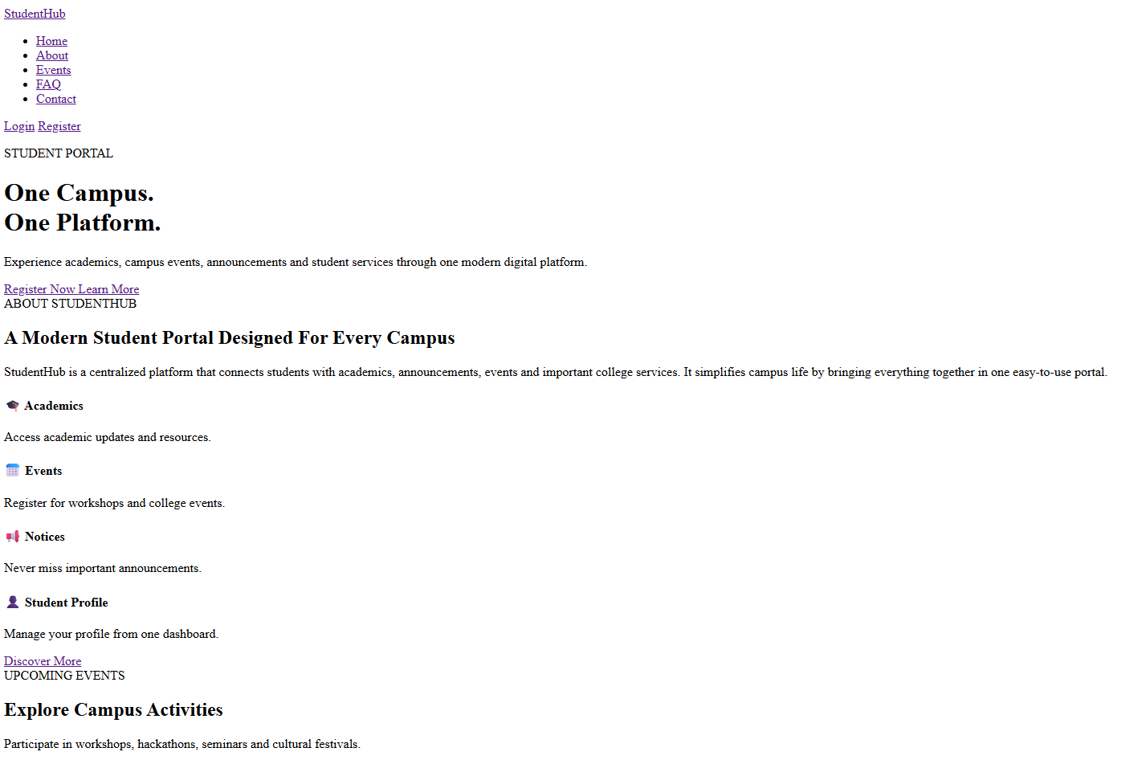
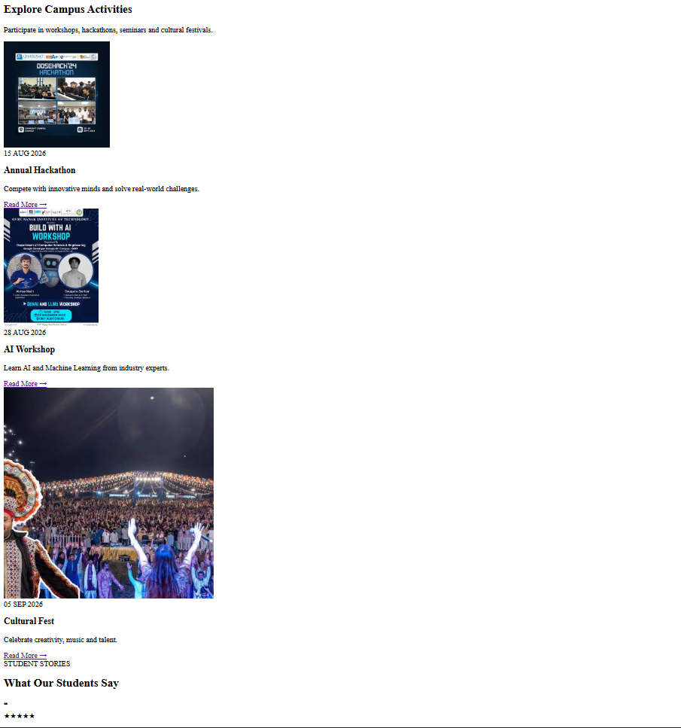
About.html:
<!DOCTYPE html>
<html lang="en">
<head>
<meta charset="UTF-8">
<meta name="viewport" content="width=device-width, initial-scale=1.0">
<title>StudentHub | About</title>
<link rel="stylesheet" href="css/about.css">
<link rel="preconnect" href="https://fonts.googleapis.com">
<link rel="preconnect" href="https://fonts.gstatic.com" crossorigin>
<link href="https://fonts.googleapis.com/css2?family=Poppins:wght@300;400;500;600&family=Playfair+Display:wght@500;600;700&display=swap" rel="stylesheet">
</head>
<body>
<header>
<nav class="navbar">
<div class="logo">
<a href="index.html">StudentHub</a>
</div>
<ul class="nav-links">
<li><a href="index.html">Home</a></li>
<li><a href="about.html">About</a></li>
<li><a href="events.html">Events</a></li>
<li><a href="faq.html">FAQ</a></li>
<li><a href="contact.html">Contact</a></li>
</ul>
<div class="nav-buttons">
<a href="login.html" class="login-btn">Login</a>
<a href="register.html" class="register-btn">Register</a>
</div>
</nav>
</header>
<section class="page-hero">
<div class="about-hero-content">
<span>ABOUT STUDENTHUB</span>
<h1>
Connecting Students.<br>
Inspiring Success.
</h1>
<p>
Learn more about our mission, vision and commitment
towards creating a better campus experience.
</p>
<div class="hero-stats">
<div class="hero-card">
<h3>5000+</h3>
<p>Students</p>
</div>
<div class="hero-card">
<h3>60+</h3>
<p>Events</p>
</div>
<div class="hero-card">
<h3>95%</h3>
<p>Placement</p>
</div>
</div>
</div>
</section>
<section class="about-main">
<div class="container">
<div class="about-text">
<span>WHO WE ARE</span>
<h2>
Empowering Students Through Technology
</h2>
<p>
StudentHub is a centralized digital platform
developed to simplify campus life. Students
can access academic information, event
registrations, announcements and their
personal profile through one integrated portal.
</p>
<p>
Our vision is to make every student feel
connected with the campus while improving
communication, participation and accessibility.
</p>
</div>
</div>
</section>
<section class="mission">
<div class="container">
<div class="mission-card">
<h3>Our Mission</h3>
<p>
To provide students with a modern,
secure and user-friendly platform
that simplifies campus life.
</p>
</div>
<div class="mission-card">
<h3>Our Vision</h3>
<p>
To create a digitally connected
campus where every student has
easy access to information.
</p>
</div>
<div class="mission-card">
<h3>Our Values</h3>
<p>
Innovation, Transparency,
Collaboration and Excellence.
</p>
</div>
</div>
</section>
<section class="why-us">
<div class="container">
<div class="section-heading">
<span>WHY CHOOSE STUDENTHUB</span>
<h2>
Built Around Students
</h2>
</div>
<div class="feature-grid">
<div class="feature-card">
<h3>Academic Resources</h3>
<p>
Notes, announcements,
syllabus and updates.
</p>
</div>
<div class="feature-card">
<h3>Campus Events</h3>
<p>
Register for workshops,
seminars and festivals.
</p>
</div>
<div class="feature-card">
<h3>Student Dashboard</h3>
<p>
Manage your activities
in one place.
</p>
</div>
<div class="feature-card">
<h3>Easy Communication</h3>
<p>
Stay connected with your
college community.
</p>
</div>
</div>
</div>
</section>
<section class="statistics">
<div class="container">
<div class="stat">
<h2>5000+</h2>
<p>Students</p>
</div>
<div class="stat">
<h2>150+</h2>
<p>Faculty Members</p>
</div>
<div class="stat">
<h2>60+</h2>
<p>Campus Events</p>
</div>
<div class="stat">
<h2>95%</h2>
<p>Placements</p>
</div>
</div>
</section>
<footer>
<div class="container footer-grid">
<div>
<h3>StudentHub</h3>
<p>
Empowering students through
technology and innovation.
</p>
</div>
<div>
<h3>Quick Links</h3>
<ul>
<li><a href="index.html">Home</a></li>
<li><a href="events.html">Events</a></li>
<li><a href="contact.html">Contact</a></li>
<li><a href="faq.html">FAQ</a></li>
</ul>
</div>
<div>
<h3>Contact</h3>
<p> Gujarat, India</p>
<p> info@studenthub.com</p>
<p>+91 9409603555</p>
</div>
</div>
<hr>
<p class="copyright">
© 2026 StudentHub. All Rights Reserved.
</p>
</footer>
</body>
</html>
Output:
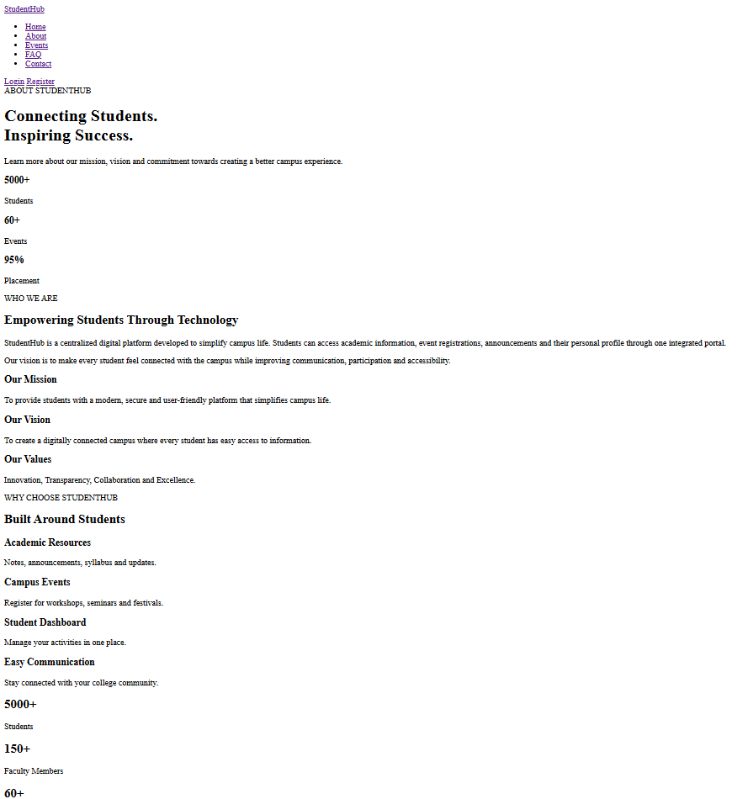
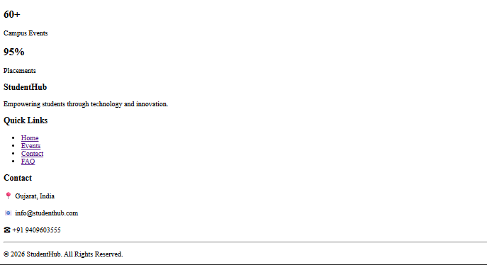
Login.html:
<!DOCTYPE html>
<html lang="en">
<head>
<meta charset="UTF-8">
<meta name="viewport" content="width=device-width, initial-scale=1.0">
<title>StudentHub | Login</title>
<link rel="stylesheet" href="css/login.css">
<link rel="preconnect" href="https://fonts.googleapis.com">
<link rel="preconnect" href="https://fonts.gstatic.com" crossorigin>
<link href="https://fonts.googleapis.com/css2?family=Poppins:wght@300;400;500;600&family=Playfair+Display:wght@500;600;700&display=swap" rel="stylesheet">
</head>
<body>
<header>
<nav class="navbar">
<div class="logo">
<a href="index.html">StudentHub</a>
</div>
<ul class="nav-links">
<li><a href="index.html">Home</a></li>
<li><a href="about.html">About</a></li>
<li><a href="events.html">Events</a></li>
<li><a href="faq.html">FAQ</a></li>
<li><a href="contact.html">Contact</a></li>
<li><a href="dashboard.html">Dashboard</li>
<li><a href="profile.html">Profile</a></li>
<li><a href="feedback.html">Feedback</a></li>
<li><a href="admin.html">Admin</a></li>
</ul>
<div class="nav-buttons">
<a href="login.html" class="login-btn">Login</a>
<a href="register.html" class="register-btn">Register</a>
</div>
</nav>
</header>
<section class="login-page">
<div class="overlay">
<div class="login-container">
<div class="login-left">
<span>WELCOME BACK</span>
<h1>
Sign In To StudentHub
</h1>
<p>
Access your dashboard, events,
announcements and profile
using your StudentHub account.
</p>
</div>
<div class="login-card">
<h2>
Login
</h2>
<form>
<label for="email">
Email Address
</label>
<input
type="email"
id="email"
placeholder="Enter your email"
required>
<label for="password">
Password
</label>
<input
type="password"
id="password"
placeholder="Enter your password"
required>
<div class="login-options">
<label>
<input type="checkbox">
Remember Me
</label>
<a href="#">
Forgot Password?
</a>
</div>
<button type="submit">
Login
</button>
</form>
<p class="register-link">
Don't have an account?
<a href="register.html">
Register
</a>
</p>
</div>
</div>
</div>
</section>
</body>
</html>
Output:
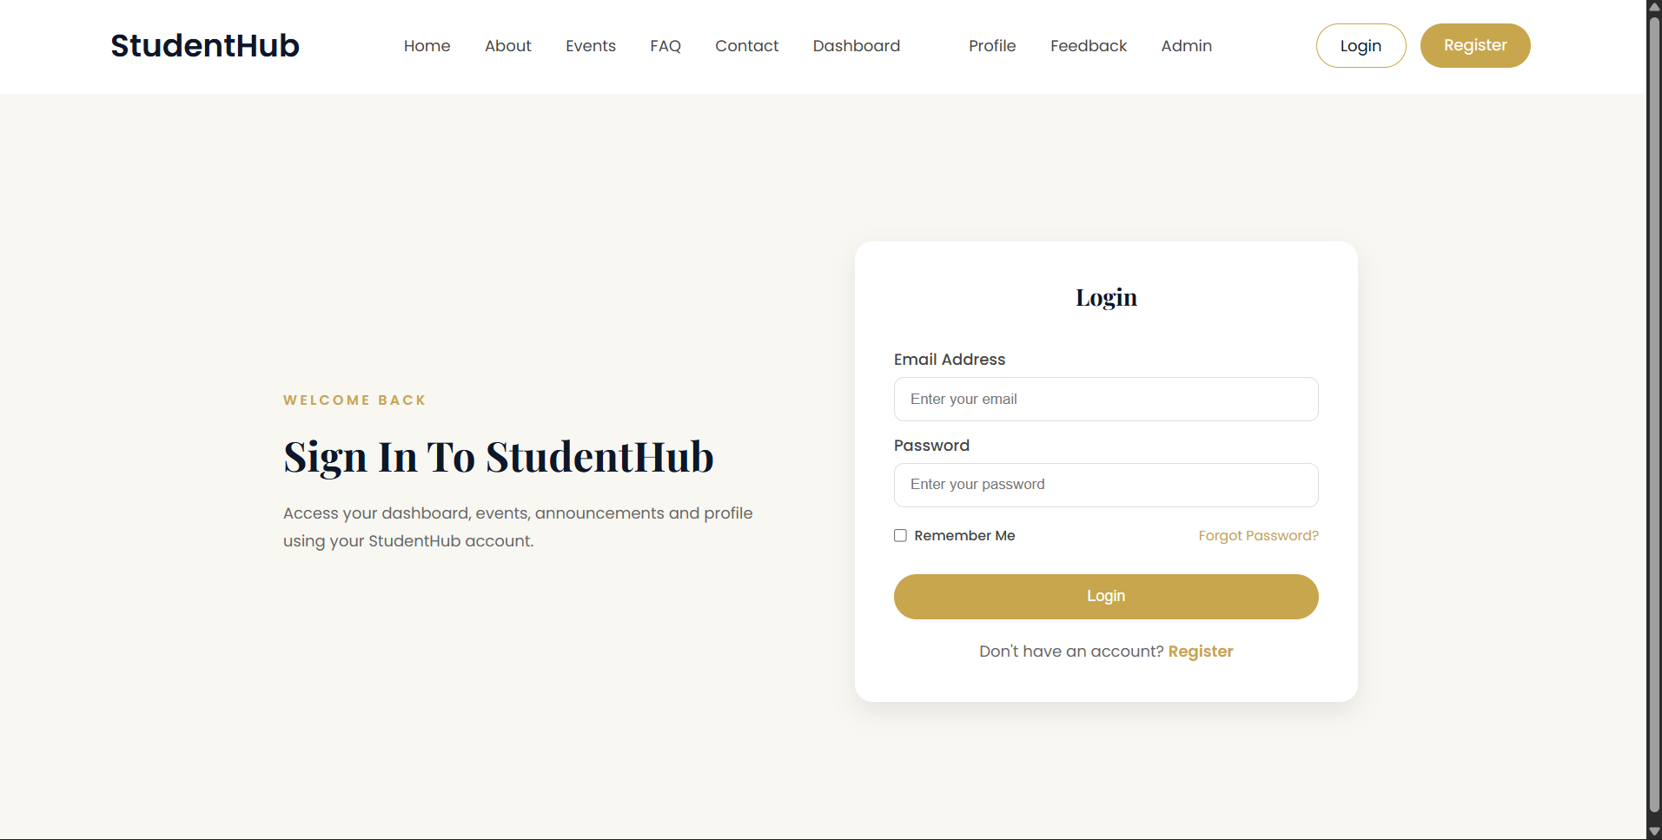
Dashboard.html:
<!DOCTYPE html>
<html lang="en">
<head>
<meta charset="UTF-8">
<meta name="viewport" content="width=device-width, initial-scale=1.0">
<title>StudentHub | Dashboard</title>
<link rel="stylesheet" href="css/style.css">
<link rel="preconnect" href="https://fonts.googleapis.com">
<link rel="preconnect" href="https://fonts.gstatic.com" crossorigin>
<link href="https://fonts.googleapis.com/css2?family=Poppins:wght@300;400;500;600&family=Playfair+Display:wght@500;700&display=swap" rel="stylesheet">
</head>
<body>
<header class="dashboard-header">
<div class="logo">
<a href="index.html">StudentHub</a>
</div>
<div class="dashboard-nav">
<a href="profile.html">Profile</a>
<a href="login.html">Logout</a>
</div>
</header>
<section class="dashboard">
<aside class="sidebar">
<h3>
Navigation
</h3>
<ul>
<li><a href="dashboard.html">Dashboard</a></li>
<li><a href="events.html">Events</a></li>
<li><a href="#">Announcements</a></li>
<li><a href="profile.html">Profile</a></li>
<li><a href="feedback.html">Feedback</a></li>
<li><a href="#">Settings</a></li>
</ul>
</aside>
<main class="dashboard-content">
<section class="welcome-card">
<h1>
Welcome Back!
</h1>
<p>
Here's what's happening on campus today.
</p>
</section>
<section class="stats">
<div class="stat-card">
<h2>05</h2>
<p>Registered Events</p>
</div>
<div class="stat-card">
<h2>12</h2>
<p>Announcements</p>
</div>
<div class="stat-card">
<h2>92%</h2>
<p>Attendance</p>
</div>
<div class="stat-card">
<h2>08</h2>
<p>Achievements</p>
</div>
</section>
<section class="dashboard-section">
<h2>
Upcoming Events
</h2>
<ul>
<li>Annual Hackathon - 15 August</li>
<li>AI Workshop - 28 August</li>
<li>Cultural Fest - 5 September</li>
</ul>
</section>
<section class="dashboard-section">
<h2>
Recent Announcements
</h2>
<ul>
<li>Semester Examination Schedule Released.</li>
<li>Library will remain open till 9 PM.</li>
<li>Registration for Sports Week has started.</li>
</ul>
</section>
<section class="dashboard-section">
<h2>
Recent Activity
</h2>
<ul>
<li>✔ Registered for Annual Hackathon</li>
<li>✔ Updated Student Profile</li>
<li>✔ Submitted Feedback Form</li>
</ul>
</section>
</main>
</section>
</body>
</html>

Output:
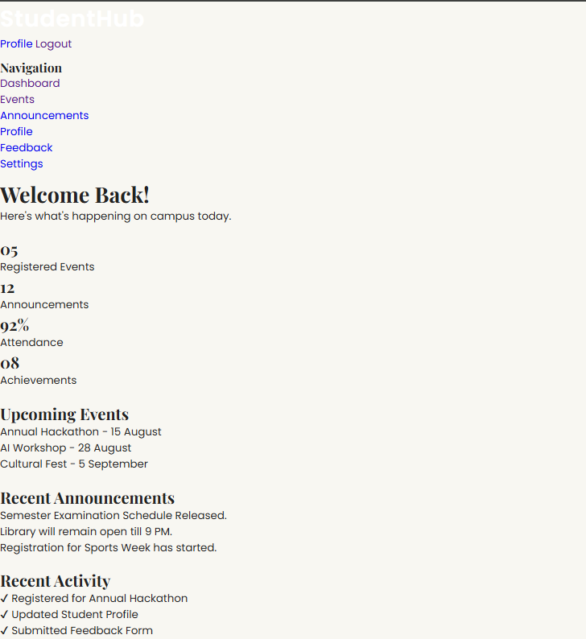
Events.html:
<!DOCTYPE html>
<html lang="en">
<head>
<meta charset="UTF-8">
<meta name="viewport" content="width=device-width, initial-scale=1.0">
<title>StudentHub | Events</title>
<link rel="stylesheet" href="css/events.css">
<link rel="preconnect" href="https://fonts.googleapis.com">
<link rel="preconnect" href="https://fonts.gstatic.com" crossorigin>
<link href="https://fonts.googleapis.com/css2?family=Poppins:wght@300;400;500;600&family=Playfair+Display:wght@500;600;700&display=swap" rel="stylesheet">
</head>
<body>
<header>
<nav class="navbar">
<div class="logo">
<a href="index.html">StudentHub</a>
</div>
<ul class="nav-links">
<li><a href="index.html">Home</a></li>
<li><a href="about.html">About</a></li>
<li><a href="events.html">Events</a></li>
<li><a href="faq.html">FAQ</a></li>
<li><a href="contact.html">Contact</a></li>
</ul>
<div class="nav-buttons">
<a href="login.html" class="login-btn">Login</a>
<a href="register.html" class="register-btn">Register</a>
</div>
</nav>
</header>
<section class="page-hero">
<div class="overlay">
<div class="hero-content">
<span>STUDENT ACTIVITIES</span>
<h1>
Campus Events
</h1>
<p>
Explore workshops, hackathons,
seminars, cultural festivals and
much more happening on campus.
</p>
</div>
</div>
</section>
<section class="upcoming-events">
<div class="container">
<h2>
Upcoming Events
</h2>
<div class="event-grid">
<article class="event-card">
<img src="images/events-hack.jpeg" alt="Hackathon">
<div class="event-info">
<span>15 August 2026</span>
<h3>
Annual Hackathon
</h3>
<p>
Participate in coding,
innovation and problem-solving.
</p>
<button>
Register
</button>
</div>
</article>

<article class="event-card">
<img src="images/event-workshop.jpeg" alt="Workshop">
<div class="event-info">
<span>28 August 2026</span>
<h3>
ROBOTICS Workshop
</h3>
<p>
Learn Robotics
from industry professionals.
</p>
<button>
Register
</button>
</div>
</article>

<article class="event-card">
<img src="images/event-music.jpeg" alt="Fest">
<div class="event-info">
<span>5 September 2026</span>
<h3>
Cultural Fest
</h3>
<p>
Music, dance,
art and entertainment.
</p>
<button>
Register
</button>
</div>
</article>
</div>
</div>
</section>
<section class="featured-event">
<div class="container">
<div class="featured-image">
<img src="images/event-feat.jpeg" alt="Featured Event">
</div>
<div class="featured-content">
<span>FEATURED EVENT</span>
<h2>
Student Innovation Summit 2026
</h2>
<p>
Join students, faculty and industry
experts for a day filled with
innovation, networking and inspiring
keynote sessions.
</p>
<a href="#" class="primary-btn">
Register Now
</a>
</div>
</div>
</section>
<section class="gallery">
<div class="container">
<h2>
Memories From Previous Events
</h2>
<div class="gallery-grid">
<img src="images/events1.jpg" alt="Gallery">
<img src="images/events2.jpg" alt="Gallery">
<img src="images/events3.jpg" alt="Gallery">
<img src="images/events4.jpg" alt="Gallery">
<img src="images/events5.jpg" alt="Gallery">
<img src="images/gallery6.jpg" alt="Gallery">
</div>
</div>
</section>
<footer>
<div class="container footer-grid">
<div>
<h3>
StudentHub
</h3>
<p>
Empowering students through
technology and innovation.
</p>
</div>
<div>
<h3>
Quick Links
</h3>
<ul>
<li><a href="index.html">Home</a></li>
<li><a href="about.html">About</a></li>
<li><a href="contact.html">Contact</a></li>
<li><a href="faq.html">FAQ</a></li>
</ul>
</div>
<div>
<h3>
Contact
</h3>
<p>📍 Gujarat, India</p>
<p>📧 info@studenthub.com</p>
<p>☎ +91 9409603555</p>
</div>
</div>
<hr>
<p class="copyright">
© 2026 StudentHub. All Rights Reserved.
</p>
</footer>
</body>
</html>
Output:
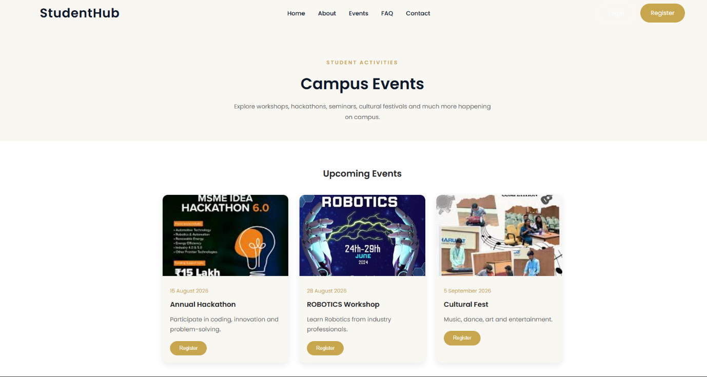
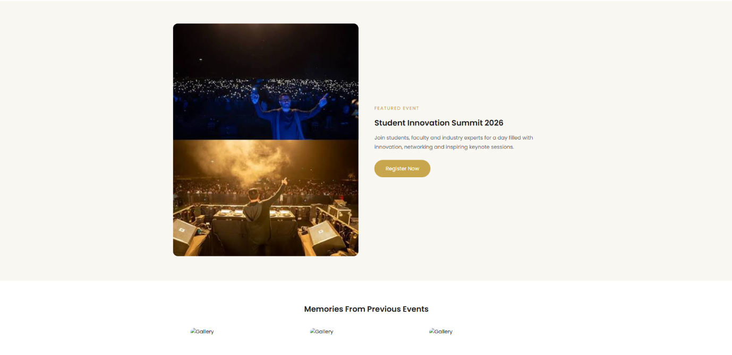
Faq.html:
<!DOCTYPE html>
<html lang="en">
<head>
<meta charset="UTF-8">
<meta name="viewport" content="width=device-width, initial-scale=1.0">
<title>StudentHub | FAQ</title>
<link rel="stylesheet" href="css/faq.css">
<link rel="preconnect" href="https://fonts.googleapis.com">
<link rel="preconnect" href="https://fonts.gstatic.com" crossorigin>
<link href="https://fonts.googleapis.com/css2?family=Poppins:wght@300;400;500;600&family=Playfair+Display:wght@500;600;700&display=swap" rel="stylesheet">
</head>
<body>
<header>
<nav class="navbar">
<div class="logo">
<a href="index.html">StudentHub</a>
</div>
<ul class="nav-links">
<li><a href="index.html">Home</a></li>
<li><a href="about.html">About</a></li>
<li><a href="events.html">Events</a></li>
<li><a href="faq.html">FAQ</a></li>
<li><a href="contact.html">Contact</a></li>
</ul>
<div class="nav-buttons">
<a href="login.html" class="login-btn">Login</a>
<a href="register.html" class="register-btn">Register</a>
</div>
</nav>
</header>
<section class="page-hero">
<div class="overlay">
<div class="hero-content">
<span>HELP CENTER</span>
<h1>
Frequently Asked Questions
</h1>
<p>
Find answers to the most common
questions about StudentHub and
campus services.
</p>
</div>
</div>
</section>
<section class="faq-section">
<div class="container">
<div class="section-heading">
<span>FAQs</span>
<h2>
How Can We Help You?
</h2>
</div>
<div class="faq-container">
<div class="faq-item">
<h3>
What is StudentHub?
</h3>
<p>
StudentHub is a centralized portal
where students can access
announcements, events,
academic updates and
profile information.
</p>
</div>

<div class="faq-item">
<h3>
How do I register?
</h3>
<p>
Click on the Register button
from the navigation bar,
fill in your details and
create your account.
</p>
</div>

<div class="faq-item">
<h3>
Can I register for events online?
</h3>
<p>
Yes. Every event page
includes a Register button
allowing students to
participate easily.
</p>
</div>

<div class="faq-item">
<h3>
How can I update my profile?
</h3>
<p>
After logging in,
open the Profile page
from your dashboard
to edit your information.
</p>
</div>

<div class="faq-item">
<h3>
What should I do if I forget my password?
</h3>
<p>
Click on the
"Forgot Password?"
option on the Login page
and follow the instructions.
</p>
</div>

<div class="faq-item">
<h3>
How do I contact the college?
</h3>
<p>
Visit the Contact page
to find phone numbers,
email addresses and
office location.
</p>
</div>
</div>
</div>
</section>
<section class="help-section">
<div class="container">
<h2>
Still Have Questions?
</h2>
<p>
If your question isn't listed here,
feel free to contact our support team.
</p>
<a href="contact.html" class="primary-btn">
Contact Us
</a>
</div>
</section>
<footer>
<div class="container footer-grid">
<div>
<h3>
StudentHub
</h3>
<p>
Empowering students through
technology and innovation.
</p>
</div>
<div>
<h3>
Quick Links
</h3>
<ul>
<li><a href="index.html">Home</a></li>
<li><a href="about.html">About</a></li>
<li><a href="events.html">Events</a></li>
<li><a href="contact.html">Contact</a></li>
</ul>
</div>
<div>
<h3>
Contact
</h3>
<p>📍 Gujarat, India</p>
<p>📧 info@studenthub.com</p>
<p>☎ +91 9409603555</p>
</div>
</div>
<hr>
<p class="copyright">
© 2026 StudentHub. All Rights Reserved.
</p>
</footer>
</body>
</html>
Output:
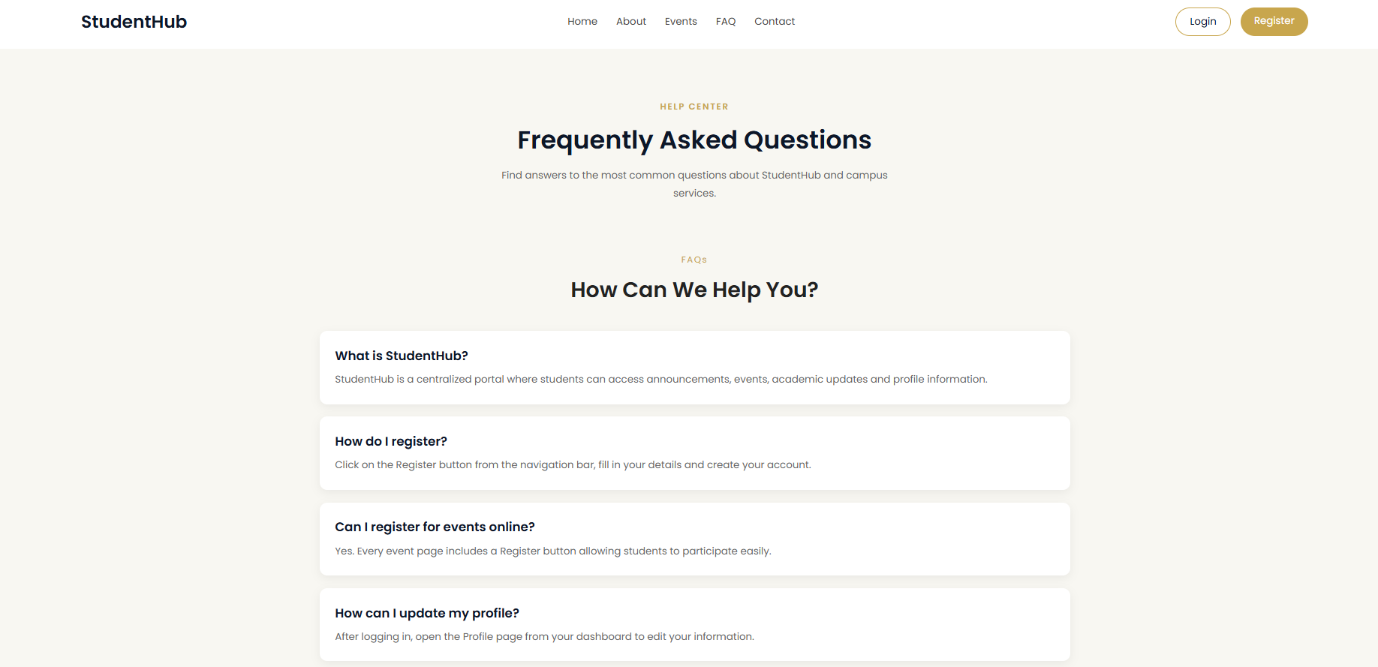
Contact.html:
<!DOCTYPE html>
<html lang="en">
<head>
<meta charset="UTF-8">
<meta name="viewport" content="width=device-width, initial-scale=1.0">
<title>StudentHub | Contact</title>
<link rel="stylesheet" href="css/contact.css">
<link rel="preconnect" href="https://fonts.googleapis.com">
<link rel="preconnect" href="https://fonts.gstatic.com" crossorigin>
<link href="https://fonts.googleapis.com/css2?family=Poppins:wght@300;400;500;600&family=Playfair+Display:wght@500;600;700&display=swap" rel="stylesheet">
</head>
<body>
<header>
<nav class="navbar">
<div class="logo">
<a href="index.html">StudentHub</a>
</div>
<ul class="nav-links">
<li><a href="index.html">Home</a></li>
<li><a href="about.html">About</a></li>
<li><a href="events.html">Events</a></li>
<li><a href="faq.html">FAQ</a></li>
<li><a href="contact.html">Contact</a></li>
</ul>
<div class="nav-buttons">
<a href="login.html" class="login-btn">Login</a>
<a href="register.html" class="register-btn">Register</a>
</div>
</nav>
</header>
<section class="page-hero">
<div class="overlay">
<div class="hero-content">
<span>GET IN TOUCH</span>
<h1>
Contact StudentHub
</h1>
<p>
We'd love to hear from you.
Reach out for support,
suggestions or any queries.
</p>
</div>
</div>
</section>
<section class="contact-info">
<div class="container">
<div class="info-card">
<h3>Address</h3>
<p>
CHARUSAT University<br>
Changa, Anand,<br>
Gujarat - 388421
</p>
</div>

<div class="info-card">
<h3>Email</h3>
<p>
info@studenthub.com
</p>
<p>
support@studenthub.com
</p>
</div>

<div class="info-card">
<h3>Phone</h3>
<p>
+91 94096 03555
</p>
<p>
+91 98765 12345
</p>
</div>
</div>
</section>
<section class="contact-form">
<div class="container">
<div class="form-left">
<span>CONTACT US</span>
<h2>
Send Us A Message
</h2>
<p>
Fill out the form below and
we'll get back to you as soon
as possible.
</p>
</div>
<div class="form-right">
<form>
<input
type="text"
placeholder="Full Name"
required>
<input
type="email"
placeholder="Email Address"
required>
<input
type="text"
placeholder="Subject"
required>
<textarea
rows="6"
placeholder="Your Message"
required>
</textarea>
<button
type="submit">
Send Message
</button>
</form>
</div>
</div>
</section>
<section class="map-section">
<div class="container">
<h2>
Find Us
</h2>
<div class="map-placeholder">
Google Map will be added here.
</div>
</div>
</section>
<section class="office-hours">
<div class="container">
<h2>
Office Hours
</h2>
<div class="hours-grid">
<div>
<h3>Monday - Friday</h3>
<p>9:00 AM - 5:00 PM</p>
</div>
<div>
<h3>Saturday</h3>
<p>9:00 AM - 1:00 PM</p>
</div>
<div>
<h3>Sunday</h3>
<p>Closed</p>
</div>
</div>
</div>
</section>
<footer>
<div class="container footer-grid">
<div>
<h3>
StudentHub
</h3>
<p>
Empowering students through
technology and innovation.
</p>
</div>

<div>
<h3>
Quick Links
</h3>
<ul>
<li><a href="index.html">Home</a></li>
<li><a href="about.html">About</a></li>
<li><a href="events.html">Events</a></li>
<li><a href="faq.html">FAQ</a></li>
</ul>
</div>
<div>
<h3>
Contact
</h3>
<p>📍 Changa, Anand, Gujarat</p>
<p>📧 info@studenthub.com</p>
<p>☎ +91 9409603555</p>
</div>
</div>
<hr>
<p class="copyright">
© 2026 StudentHub. All Rights Reserved.
</p>
</footer>
</body>
</html>
Output:
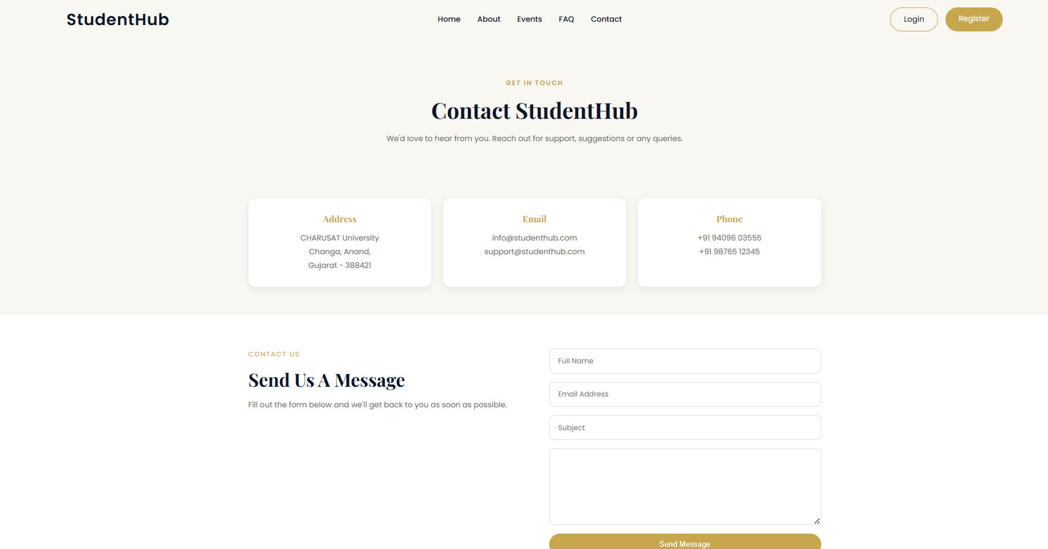
Admin.html:
<!DOCTYPE html>
<html lang="en">
<head>
<meta charset="UTF-8">
<meta name="viewport" content="width=device-width, initial-scale=1.0">
<title>StudentHub | Contact</title>
<link rel="stylesheet" href="css/contact.css">
<link rel="preconnect" href="https://fonts.googleapis.com">
<link rel="preconnect" href="https://fonts.gstatic.com" crossorigin>
<link href="https://fonts.googleapis.com/css2?family=Poppins:wght@300;400;500;600&family=Playfair+Display:wght@500;600;700&display=swap" rel="stylesheet">
</head>
<body>
<header>
<nav class="navbar">
<div class="logo">
<a href="index.html">StudentHub</a>
</div>
<ul class="nav-links">
<li><a href="index.html">Home</a></li>
<li><a href="about.html">About</a></li>
<li><a href="events.html">Events</a></li>
<li><a href="faq.html">FAQ</a></li>
<li><a href="contact.html">Contact</a></li>
</ul>
<div class="nav-buttons">
<a href="login.html" class="login-btn">Login</a>
<a href="register.html" class="register-btn">Register</a>
</div>
</nav>
</header>
<section class="page-hero">
<div class="overlay">
<div class="hero-content">
<span>GET IN TOUCH</span>
<h1>
Contact StudentHub
</h1>
<p>
We'd love to hear from you.
Reach out for support,
suggestions or any queries.
</p>
</div>
</div>
</section>
<section class="contact-info">
<div class="container">
<div class="info-card">
<h3>Address</h3>
<p>
CHARUSAT University<br>
Changa, Anand,<br>
Gujarat - 388421
</p>
</div>

<div class="info-card">
<h3>Email</h3>
<p>
info@studenthub.com
</p>
<p>
support@studenthub.com
</p>
</div>

<div class="info-card">
<h3>Phone</h3>
<p>
+91 94096 03555
</p>
<p>
+91 98765 12345
</p>
</div>
</div>
</section>
<section class="contact-form">
<div class="container">
<div class="form-left">
<span>CONTACT US</span>
<h2>
Send Us A Message
</h2>
<p>
Fill out the form below and
we'll get back to you as soon
as possible.
</p>
</div>
<div class="form-right">
<form>
<input
type="text"
placeholder="Full Name"
required>
<input
type="email"
placeholder="Email Address"
required>
<input
type="text"
placeholder="Subject"
required>
<textarea
rows="6"
placeholder="Your Message"
required>
</textarea>
<button
type="submit">
Send Message
</button>
</form>
</div>
</div>
</section>
<section class="map-section">
<div class="container">
<h2>
Find Us
</h2>
<div class="map-placeholder">
Google Map will be added here.
</div>
</div>
</section>
<section class="office-hours">
<div class="container">
<h2>
Office Hours
</h2>
<div class="hours-grid">
<div>
<h3>Monday - Friday</h3>
<p>9:00 AM - 5:00 PM</p>
</div>
<div>
<h3>Saturday</h3>
<p>9:00 AM - 1:00 PM</p>
</div>
<div>
<h3>Sunday</h3>
<p>Closed</p>
</div>
</div>
</div>
</section>
<footer>
<div class="container footer-grid">
<div>
<h3>
StudentHub
</h3>
<p>
Empowering students through
technology and innovation.
</p>
</div>

<div>
<h3>
Quick Links
</h3>
<ul>
<li><a href="index.html">Home</a></li>
<li><a href="about.html">About</a></li>
<li><a href="events.html">Events</a></li>
<li><a href="faq.html">FAQ</a></li>
</ul>
</div>
<div>
<h3>
Contact
</h3>
<p>📍 Changa, Anand, Gujarat</p>
<p>📧 info@studenthub.com</p>
<p>☎ +91 9409603555</p>
</div>
</div>
<hr>
<p class="copyright">
© 2026 StudentHub. All Rights Reserved.
</p>
</footer>
</body>
</html>
Output:
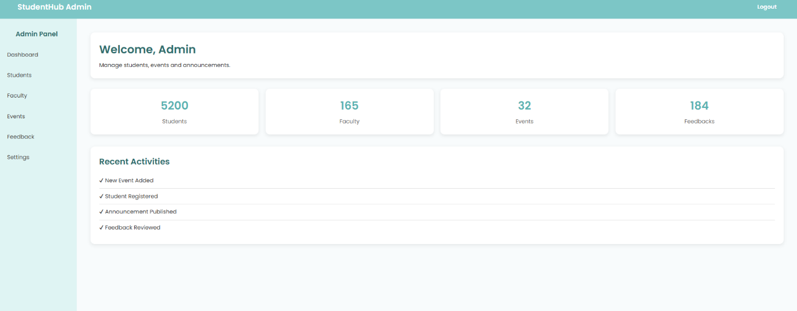
Profile.html:
<!DOCTYPE html>
<html lang="en">
<head>
<meta charset="UTF-8">
<meta name="viewport" content="width=device-width, initial-scale=1.0">
<title>StudentHub | Profile</title>
<link rel="stylesheet" href="css/style.css">
</head>
<body>
<header>
<nav class="navbar">
<div class="logo">
<a href="index.html">StudentHub</a>
</div>
<ul class="nav-links">
<li><a href="index.html">Home</a></li>
<li><a href="dashboard.html">Dashboard</a></li>
<li><a href="events.html">Events</a></li>
<li><a href="contact.html">Contact</a></li>
</ul>
<div class="nav-buttons">
<a href="login.html" class="login-btn">Logout</a>
</div>
</nav>
</header>

<section class="profile">
<div class="container">
<div class="profile-card">
<img src="profile.jpg" alt="Student">
<h2>Vaidehi Parmar</h2>
<p>Computer Engineering</p>
<p>Semester 1</p>
<p>Enrollment No: 24CE001</p>
<a href="#" class="primary-btn">Edit Profile</a>
</div>

<div class="profile-info">
<h2>Personal Information</h2>
<ul>
<li><strong>Email :</strong> vaidehi@email.com</li>
<li><strong>Phone :</strong> +91 9876543210</li>
<li><strong>College :</strong> CHARUSAT</li>
<li><strong>Attendance :</strong> 92%</li>
<li><strong>Achievements :</strong> 8</li>
</ul>
</div>
</div>
</section>
</body>
</html>
Output:
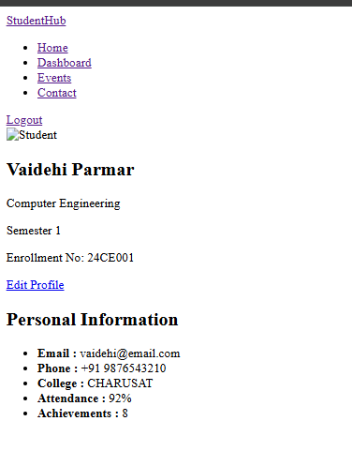
Register.html:
<!DOCTYPE html>
<html lang="en">
<head>
<meta charset="UTF-8">
<meta name="viewport" content="width=device-width, initial-scale=1.0">
<title>StudentHub | Register</title>
<link rel="stylesheet" href="css/register.css">
<link rel="preconnect" href="https://fonts.googleapis.com">
<link rel="preconnect" href="https://fonts.gstatic.com" crossorigin>
<link href="https://fonts.googleapis.com/css2?family=Poppins:wght@300;400;500;600&family=Playfair+Display:wght@500;600;700&display=swap" rel="stylesheet">
</head>
<body>
<header>
<nav class="navbar">
<div class="logo">
<a href="index.html">StudentHub</a>
</div>
<ul class="nav-links">
<li><a href="index.html">Home</a></li>
<li><a href="about.html">About</a></li>
<li><a href="events.html">Events</a></li>
<li><a href="faq.html">FAQ</a></li>
<li><a href="contact.html">Contact</a></li>
</ul>
<div class="nav-buttons">
<a href="login.html" class="login-btn">Login</a>
<a href="register.html" class="register-btn">Register</a>
</div>
</nav>
</header>
<section class="register-page">
<div class="overlay">
<div class="register-container">
<div class="register-left">
<span>
JOIN STUDENTHUB
</span>
<h1>
Create Your Student Account
</h1>
<p>
Become a part of StudentHub and
enjoy seamless access to academics,
events, announcements and your
personalized dashboard.
</p>
</div>
<div class="register-card">
<h2>
Register
</h2>
<form>
<label for="name">
Full Name
</label>
<input
type="text"
id="name"
placeholder="Enter your full name"
required>

<label for="email">
Email Address
</label>
<input
type="email"
id="email"
placeholder="Enter your email"
required>

<label for="studentid">
Student ID
</label>
<input
type="text"
id="studentid"
placeholder="Enter your Student ID"
required>

<label for="department">
Department
</label>
<select id="department">
<option>Select Department</option>
<option>Computer Engineering</option>
<option>Information Technology</option>
<option>Computer Science & Engineering</option>
<option>Mechanical Engineering</option>
<option>Civil Engineering</option>
</select>

<label for="semester">
Semester
</label>
<select id="semester">
<option>Select Semester</option>
<option>Semester 1</option>
<option>Semester 2</option>
<option>Semester 3</option>
<option>Semester 4</option>
<option>Semester 5</option>
<option>Semester 6</option>
<option>Semester 7</option>
<option>Semester 8</option>
</select>
<label for="password">
Password
</label>
<input
type="password"
id="password"
placeholder="Create a password"
required>

<label for="confirm">
Confirm Password
</label>
<input
type="password"
id="confirm"
placeholder="Confirm your password"
required>

<button type="submit">
Create Account
</button>
</form>
<p class="login-link">
Already have an account?
<a href="login.html">
Login
</a>
</p>
</div>
</div>
</div>
</section>
</body>
</html>

Output:
